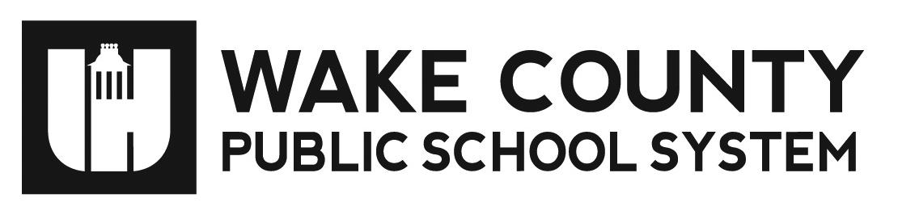

**Annual Parent Notice**

**Right to Request Teacher Qualifications**

Yates Mill Elementary School September 27, 2022

Dear Parent /Guardian:

Our school receives federal funds for Title I programs that are part of the *Every Student Succeeds Act (ESSA).* Throughout the school year, we will continue to provide you with important information about this law and your child’s education.

You have the right to request information regarding the professional qualifications of your child’s classroom teacher(s). If you request this information, the district or school will provide you with the following as soon as possible:

1. if the teacher has met state licensing requirements for the grade level and subjects in which the teacher is providing instruction;
2. if the teacher is teaching under an emergency status for which state licensing requirements have been waived;
3. the type of college degree major of the teacher and the field of discipline for any graduate degree or certificate; and
4. if your child is receiving Title I services from paraprofessionals and, if so, his/her qualifications.

If you would like to request this information, please contact Abby Greenberg

Thank you for your interest and involvement in your child’s education.

Sincerely,

Abby Greenberg

Literacy Coach/Instructional Facilitator

agreenberg@wcpss.net